Horsemens Adult Riders Club
MEMBERSHIP APPLICATION – 2026

Name : _________________________________________________________________

Address : _________________________________________________________________

Suburb : ____________________________________ Postcode : ____________

Telephone: Home _________________________ Mobile ___________________________

Email Address ____________________________________

Facebook Profile Name ____________________________________

Type of Membership applying for:

Membership ($260 total): YES/NO

Please tick below to confirm if paying in full or whether taking split option payment ($130 by 14 Dec, $130 by 31 Jan)

Full Payment Split Payment

Social Membership only ($30 total): YES/NO

I am an EWA Member YES / NO

Membership Number: ____________________________
** Please ensure your EWA membership is current if advising you are a member **

- I acknowledge that I have read and understood the 2026 HARC Membership Pack and the terms and conditions of membership, including the Helper Duties requirements.
- I have signed the EWA Waiver form if I am applying for full membership.
- I declare that I am 18 years of age or over.
- I agree to the sharing of photos from rallies and social events on the HARC website and social media. If you’d prefer not to have your photos used, please send an email to the secretary to let us know.

SIGNED: ____________________________________ DATE : ____ / ____ / ______

Note: Members must complete and return all forms and have paid membership fees in full to participate in rallies for insurance and safety purposes.


EMERGENCY CONTACT DETAILS 2026
Forms Apply to Full Members only

(Strictly Confidential - for use in Emergency Only)

Rider Name:
Date of Birth:
Medicare Number:
Private Ambulance Cover Held: Yes / No
Emergency Contact(s):
(1) Name:
Contact Phone No:
(2) Name:
Contact Phone No:
Usual Medical Practitioner:
Name:
Contact Phone No:
Allergies: (Please Specify)

Rider's Medical Condition(s)
& Regular Medications:

The information above will be held in the strictest confidence and only used in an emergency situation

Horsemens Adult Riders Club
Applicable to Full Members only 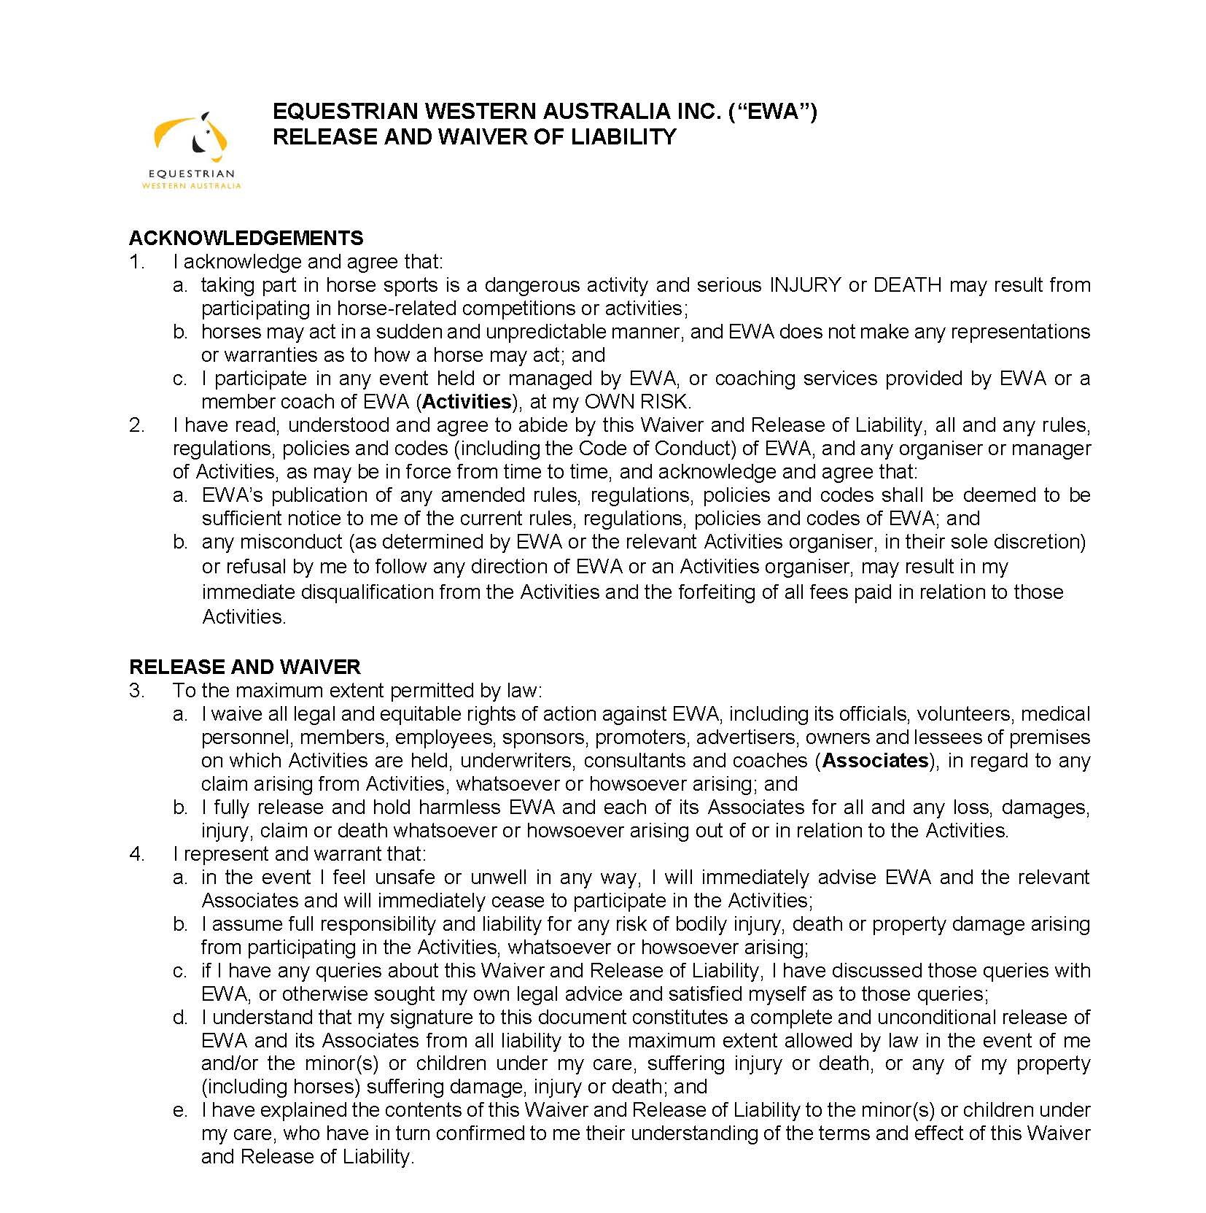

NAME: _______________________________ DATE OF BIRTH ____ / ____ / ______

SIGNED: _______________________________ DATE : ____ / ____ / ______

